Queen (1LP)  Side 1  - Keep Yourself Alive  - Doing All Right  - Great King Rat  - My Fairy King  Side 2  - Liar  - The Night Comes Down  - Modern Times Rock ‘N’ Roll  - Son And Daughter  - Jesus  - Seven Seas Of Rhye | 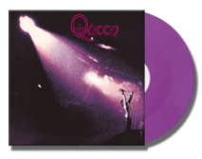
Queen II (2LP)  LP1 – Side 1 (white side)  - Procession  - Father To Son  - White Queen (As It Begins)  - Some Day One Day  - The Loser In The End  LP1 – Side 2  Etching  LP2 - Side 1 (black side)  - Ogre Battle  - The Fairy Feller’s Master-Stroke  - Nevermore  - The March Of The Black Queen  - Funny How Love Is  - The Seven Seas Of Rhye  LP2 – Side 2  Etching | 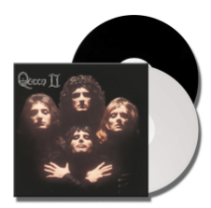
Sheer Heart Attack (1LP)  Side 1  - Brighton Rock  - Killer Queen  - Tenement Funster  - Flick Of The Wrist  - Lily Of The Valley  - Now I’m Here  Side 2  - In The Lap Of The Gods  - Stone Cold Crazy  - Dear Friends  - Misfire  - Bring Back That Leroy Brown  - She Makes Me (Stormtrooper In Stilettoes)  - In The Lap Of The Gods…Revisited | 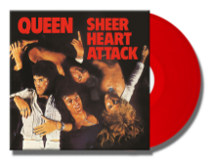
A Night At The Opera (1LP)  Side 1  - Death On Two Legs (Dedicated To…)  - Lazing On A Sunday Afternoon  - I’m In Love With My Car  - You’re My Best Friend  - ‘39  - Sweet Lady  - Seaside Rendezvous  Side 2  - The Prophet’s Song  - Love Of My Life  - Good Company  - Bohemian Rhapsody  - God Save The Queen | 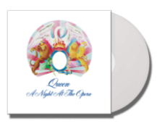
A Day At The Races (1LP)  Side 1  - Tie Your Mother Down  - You Take My Breath Away  - Long Away  - The Millionaire Waltz  - You And I  Side 2  - Somebody To Love  - White Man  - Good Old-Fashioned Lover Boy  - Drowse  - Teo Torriatte (Let Us Cling Together) | 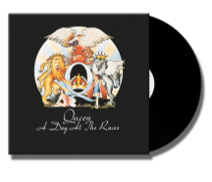
News Of The World (1LP)  Side 1  - We Will Rock You  - We Are The Champions  - Sheer Heart Attack  - All Dead, All Dead  - Spread Your Wings  - Fight From The Inside  Side 2  - Get Down, Make Love  - Sleeping On The Sidewalk  - Who Needs You  - It’s Late  - My Melancholy Blues | 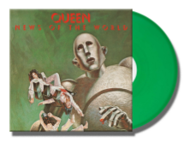
Jazz (1LP)  Side 1  - Mustapha  - Fat Bottomed Girls  - Jealousy  - Bicycle Race  - If You Can’t Beat Them  - Let Me Entertain You  Side 2  - Dead On Time  - In Only Seven Days  - Dreamers Ball  - Fun It  - Leaving Home Ain’t Easy  - Don’t Stop Me Now  - More Of That Jazz | 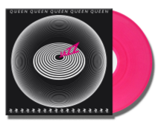
The Game (1LP)  Side 1  - Play The Game  - Dragon Attack  - Another One Bites The Dust  - Need Your Loving Tonight  - Crazy Little Thing Called Love  Side 2  - Rock It (Prime Jive)  - Don’t Try Suicide  - Sail Away Sweet Sister  - Coming Soon  - Save Me | 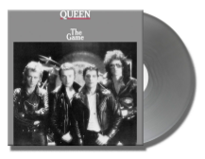
Flash Gordon (1LP)  Side 1  - Flash’s Theme  - In The Space Capsule (The Love Theme)  - Ming’s Theme (In The Court Of Ming The Merciless)  - The Ring (Hypnotic Seduction Of Dale)  - Football Fight  - In The Death Cell (Love Theme Reprise)  - Execution Of Flash  - The Kiss (Aura Resurrects Flash)  Side 2  - Arboria (Planet Of The Tree Men)  - Escape From The Swamp  - Flash To The Rescue  - Vultan’s Theme (Attack Of The Hawk Men)  - Battle Theme  - The Wedding March  - Marriage Of Dale And Ming (And Flash Approaching)  - Crash Dive On Mingo City  - Flash’s Theme Reprise (Victory Celebrations)  - The Hero | 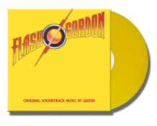
Hot Space (1LP)  Side 1  - Staying Power  - Dancer  - Back Chat  - Body Language  - Action This Day  Side 2  - Put Out The Fire  - Life Is Real (Song For Lennon)  - Calling All Girls  - Las Palabras De Amor (The Words Of Love)  - Cool Cat  - Under Pressure | 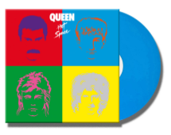
The Works (1LP)  Side 1  - Radio GaGa  - Tear It Up  - It’s A Hard Life  - Man On The Prowl  Side 2  - Machines (Or Back To Humans)  - I Want To Break Free  - Keep Passing The Open Windows  - Hammer To Fall  - Is This The World We Created? | 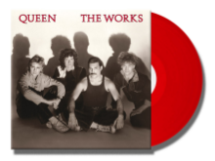
A Kind Of Magic (1LP)  Side 1  - One Vision  - A Kind Of Magic  - One Year Of Love  - Pain Is So Close To Pleasure  - Friends Will Be Friends  Side 2  - Who Wants To Live Together  - Gimme The Prize (Kurgan’s Theme)  - Don’t Lose Your Head  - Princes Of The Universe | 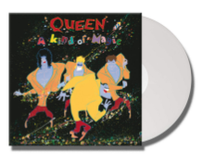
The Miracle (1LP)  Side 1  - Party  - Khashoggi’s Ship  - The Miracle  - I Want It All  - The Invisible Man  Side 2  - Breakthru  - Rain Must Fall  - Scandal  - My Baby Does Me  - Was It Worth It | 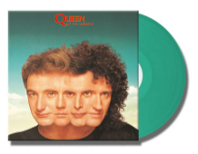
Innuendo (2LP) – side splits TBC  Side 1  - Innuendo  - I’m Going Slightly Mad  - Headlong  - I Can’t Live Without You  - Ride The Wild Wind  Side 2  - All God’s People  - These Are The Days Of Our Lives  - Delilah  - Don’t Try So Hard  - The Hitman  - Bijou  - The Show Must Go On | 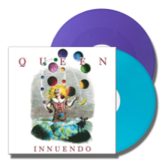
Made In Heaven (2LP) – side splits TBC  Side 1  - It’s A Beautiful Day  - Made In Heaven  - Let Me Live  - Mother Love  - My Life Has Been Saved  Side 2  - I Was Born To Love You  - Heaven For Everyone  - Too Much Love Will Kill You  - You Don’t Fool Me  - A Winter’s Tale  - It’s A Beautiful Day (Reprise) | 